Model 1:
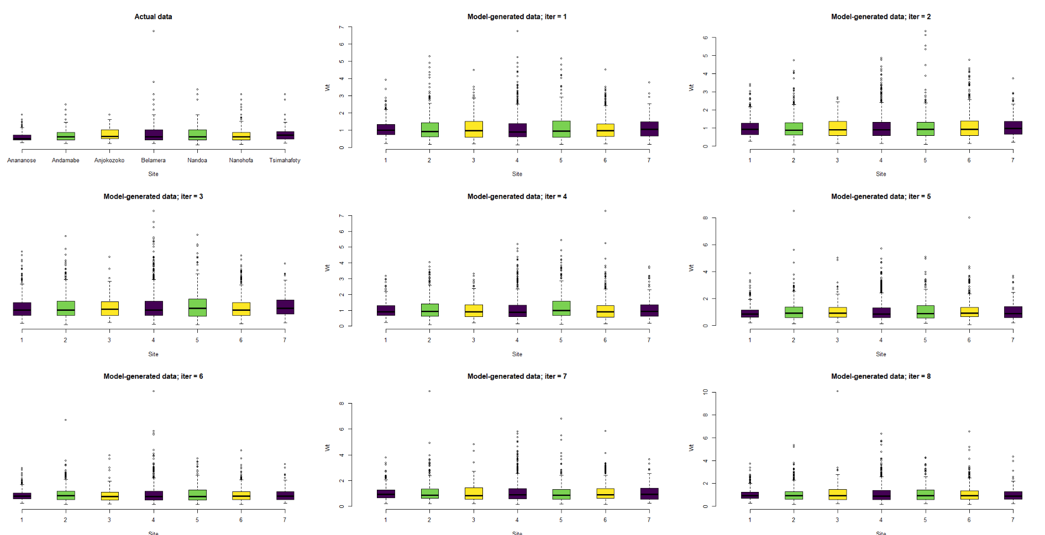
print(exp(out_stwt$BUGSoutput$sims.list$alpha[1,]))
[1] 0.6953878
0.8256599
0.8372189
0.9341983
0.8490554
0.8128602
0.9197955
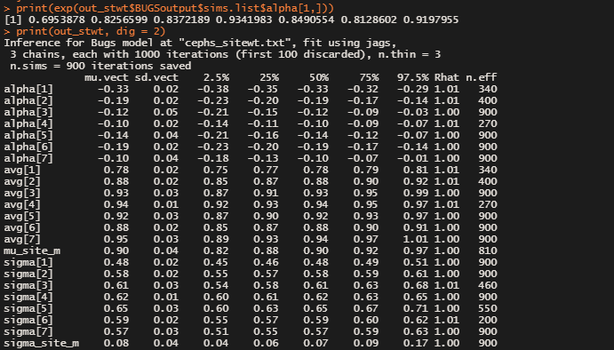
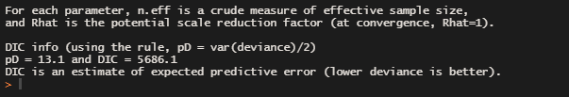
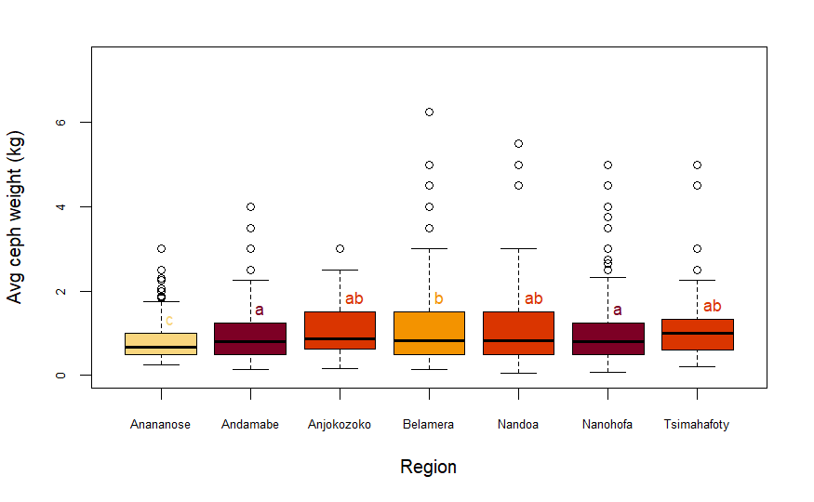
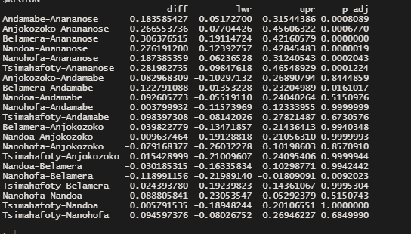
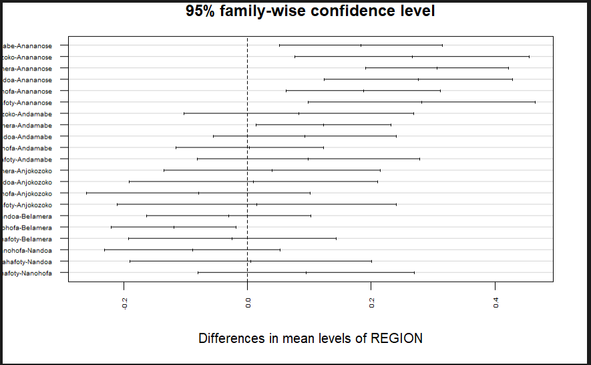
Compare to what happens if you decrease 95%

Model 2
Freq ttest
